Man.GA

Project of introduction to web programming

Léo MERY Florian ERNST



Table of content

Introduction 2

I- Home page 3

II- Manga Information 4

III- Header 6

IV- Manga list 7

V- The registration system 9

VI- Profile 10

VII- Footer 11

# Introduction

Man.ga is a website where you can discover new manga and see information on your favourite ones. With a lot of types and genres of manga, you can expand your horizons to new kinds of adventures.

We want to make a site that includes a database of manga data. We want it to be possible to obtain various information such as genres, author and even a description for each of the works we propose. In addition, we want visitors to our site to be able to have an impact and feel involved, which is why we want to set up a scoring system, favourites and comments in order to get the readers' point of view. And because we think that visitors can bring us a lot, we also want to set up a page where they can contact us. For this reason, we plan to build our website in the following way:

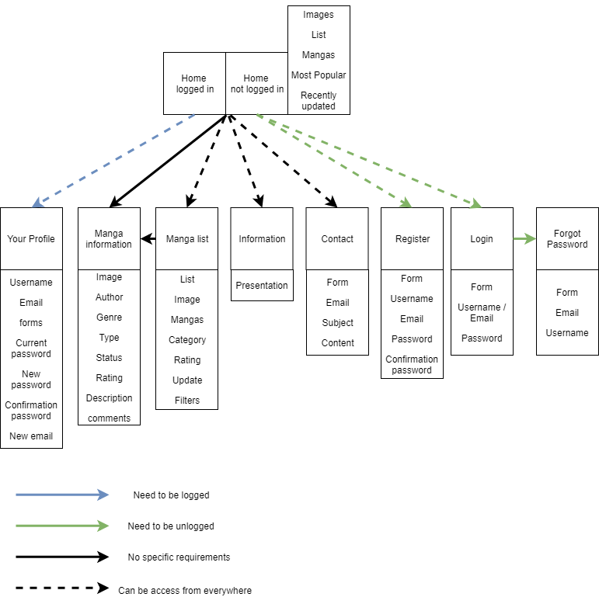Man.ga outline

# I- Home page

In our opinion, the home page is very important, because it must present the most important information for a person who comes to our page for the first time or infrequently. But it must also contain the most recent information, so that a person who often visits our page can see at a glance if there are or not any new features. That's why we have chosen to display on our home page, the 5 most popular manga of the moment for casual people, as well as the 5 most recently updated manga for daily visitors.

Here is a schematic representing the overall idea we have of the home page:

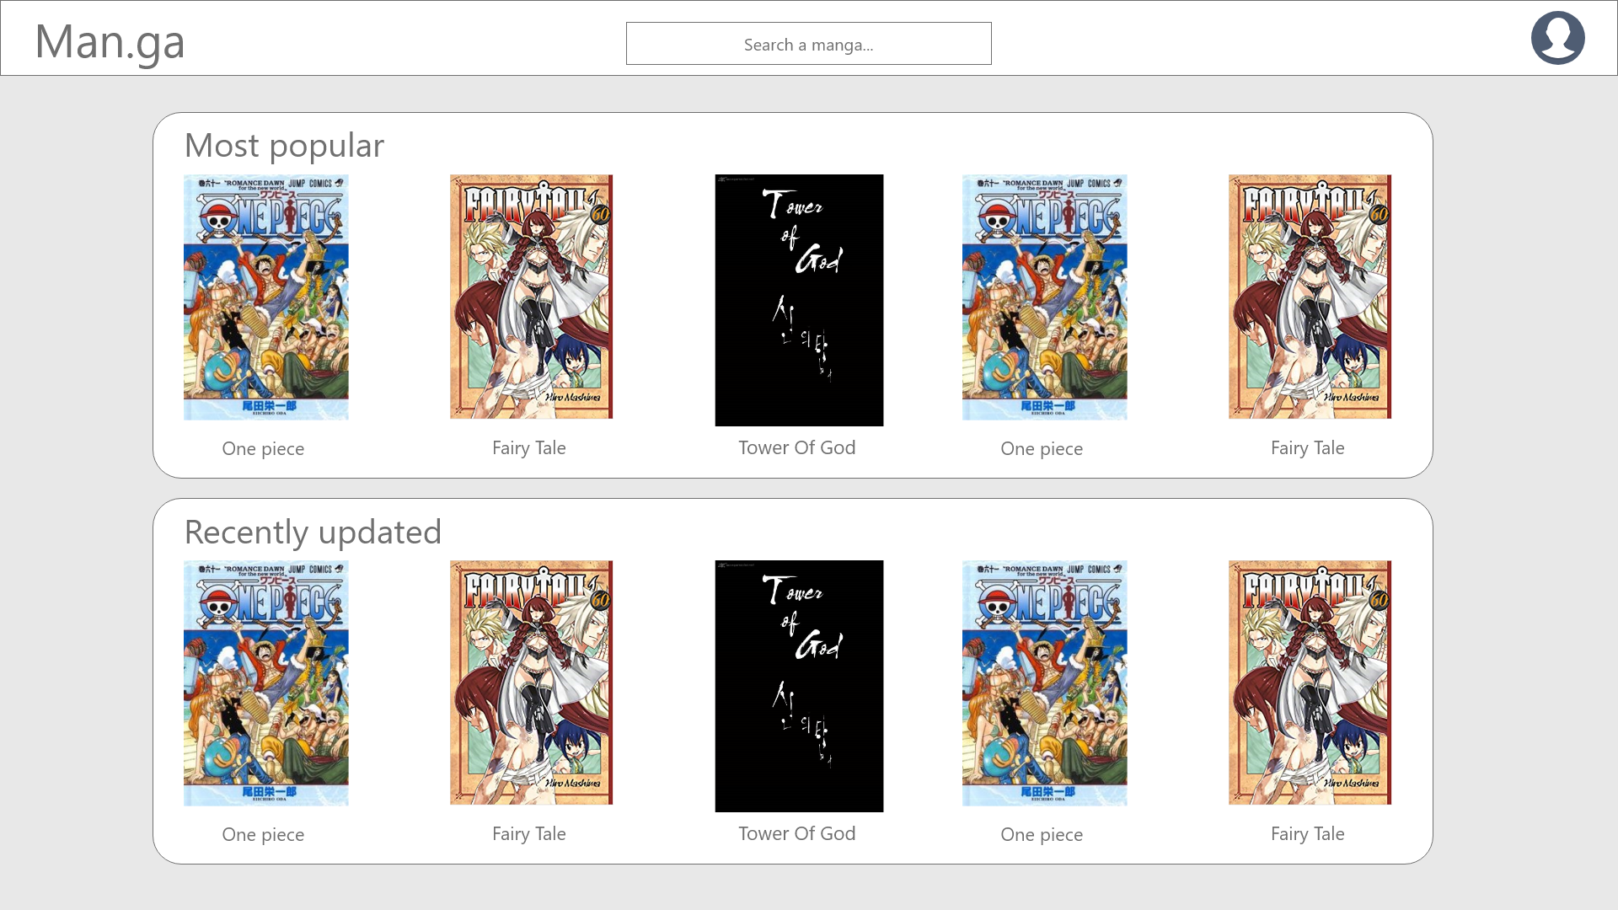

# II- Manga Information

This page is accessible when the visitor clicks on a manga title or one of the available covers either on the home page or on the page giving access to the entire manga list. It then gives access to the manga file. On it you will find a lot of information such as the name of the author, the type and genre of the work, its publication status, its rating out of 10 as well as the number of people who voted the rating you have given if you are registered and a brief description of the work.

The type is linked to the demographic target of the manga. The main types are Shonen for boys/adolescents, Shojo for girls/adolescents, Seinen for adults (mostly men), Josei for adults (mostly women), and Kodomomuke for young children.

The genre is the kind of actions happening in the manga. Most common are Action, Adventure, Romance, Fantasy, Drama.

The publication status of the manga is either ongoing or completed.

Finally, we planned a comment feed in which the visitor can share with other visitors his passion for this manga or its author.

Not yet knowing how to link our site to databases, we have made a standard page to which all manga are currently linked, obviously in our final version, all manga will be linked to their own and only information page.

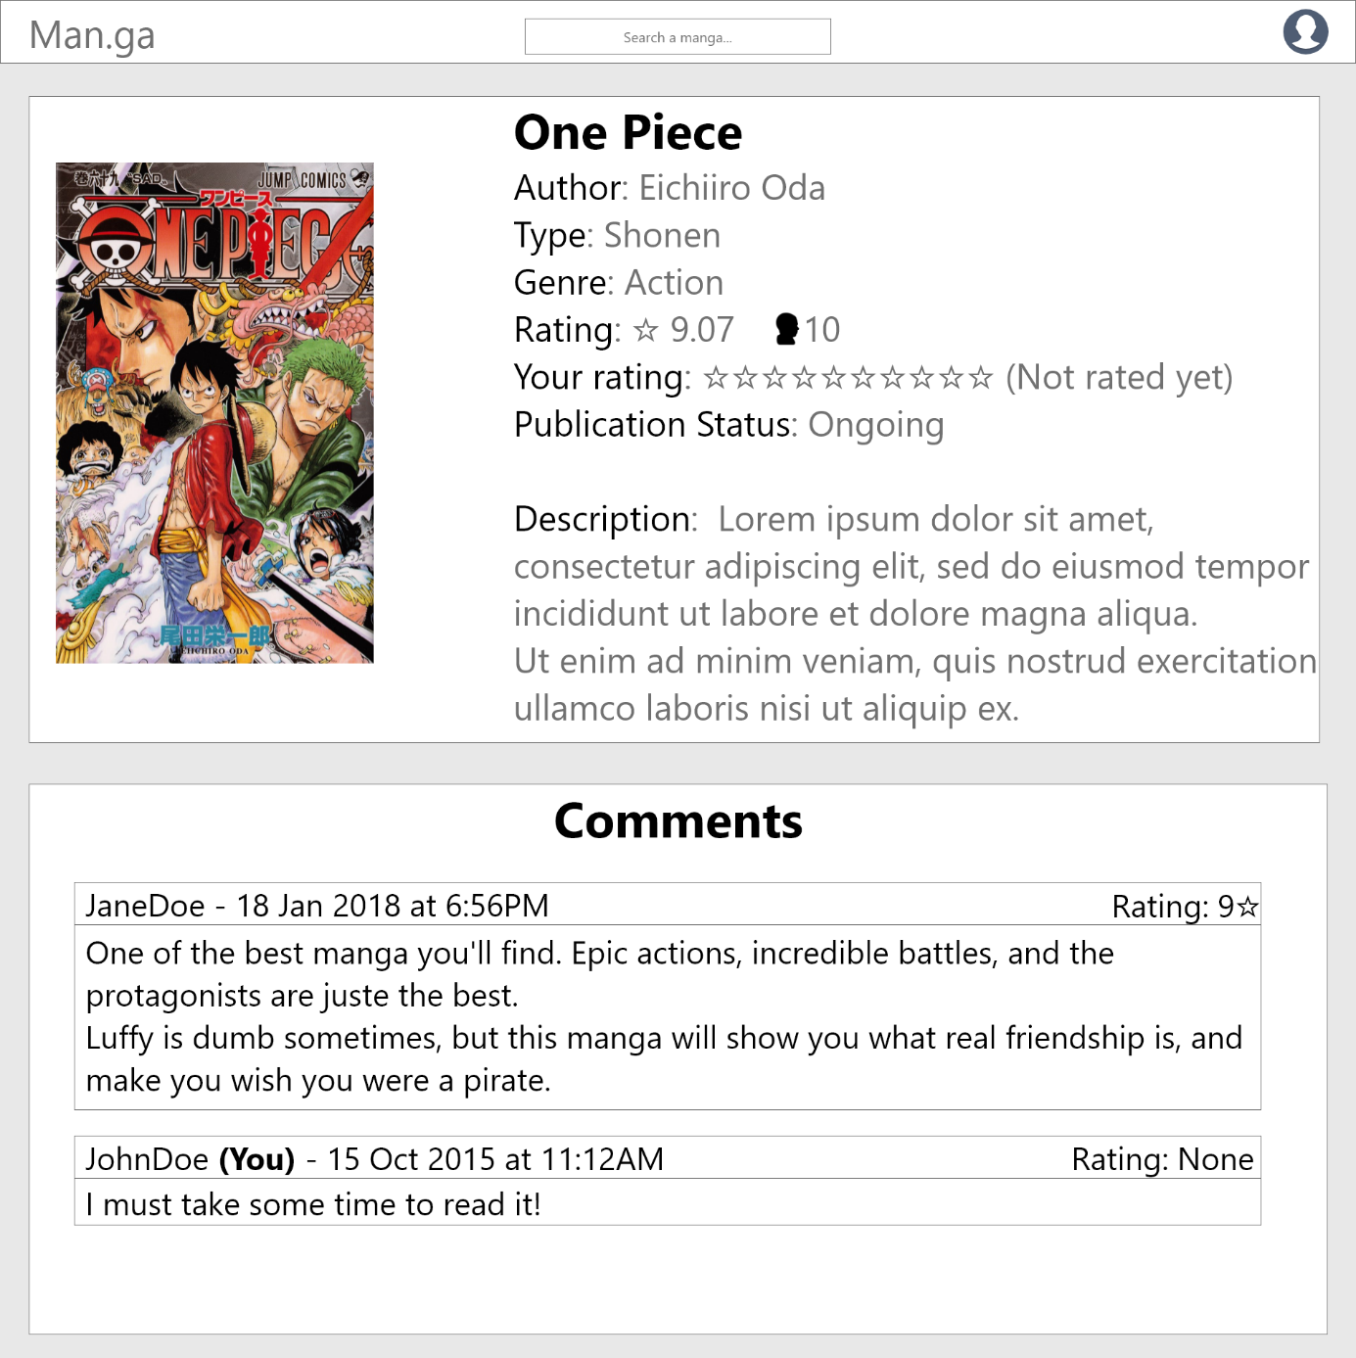

# III- Header

The header of our site will be available from any page and will present the following information, a Man.ga link to the home page when you click on it, a search bar to easily find the manga you are looking for, a link to the complete list of manga on our site, the ability to register or connect to our site, and in which it has already been made a link to our profile and a sign out button.

# IV- Manga list

From the header it is possible to access the entirety of our manga list and not just the most popular or recently updated ones. We want to display a vertical list of each of the available works with:

- their cover  
- the title of the work  
- its number of current chapters  
- its category including its type and genre  
-its rating and its latest update date  
-for connected people only, the possibility to add the work to your favourites. To do this, simply click on the black star, it will then light up in yellow and the work will be added to the favourites. If, on the other hand, you want to remove the manga from the favourites, it will just be enough to do the opposite.

In order to facilitate navigation in this list, we also want to integrate a system of filters that should be both intuitive and complete, because even if our list is currently very short, we hope to expand it as much as possible in order to provide a more complete site.  
For this purpose we offer different filters

- the type  
- the genres  
- the status of the work  
- its minimum score  
- and whether the work is one of the favourites.

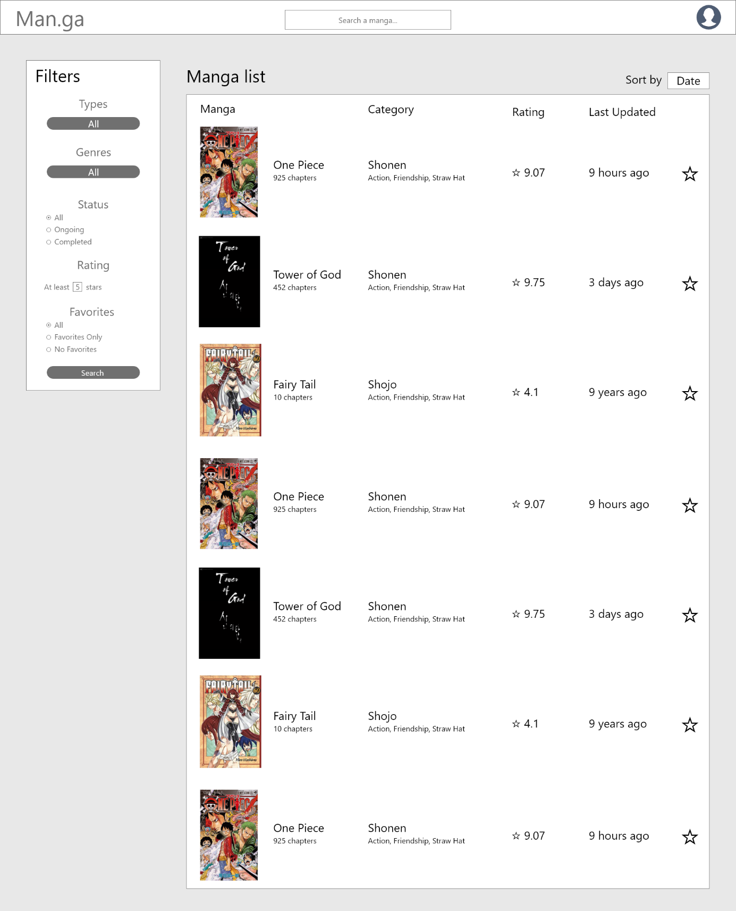

# V- The registration system

Still in the header, it is possible to access the account creation page if you are not registered on the site or the registration page if you are not.

the account creation page will ask you to choose a username, enter an email address, type a password, confirm the password

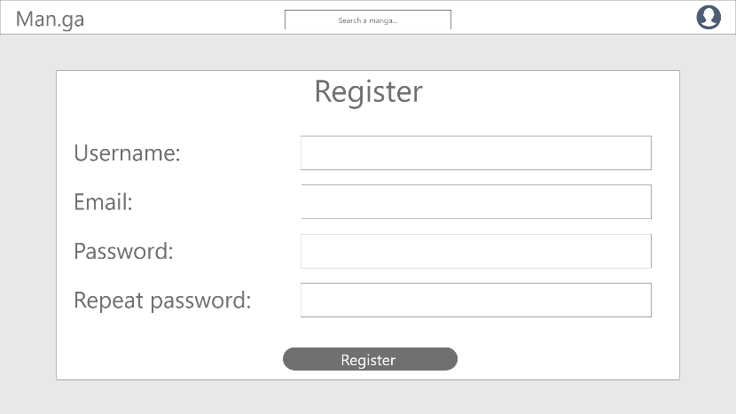

To connect, all you have to do is enter either the username or the email followed by the password in the field.

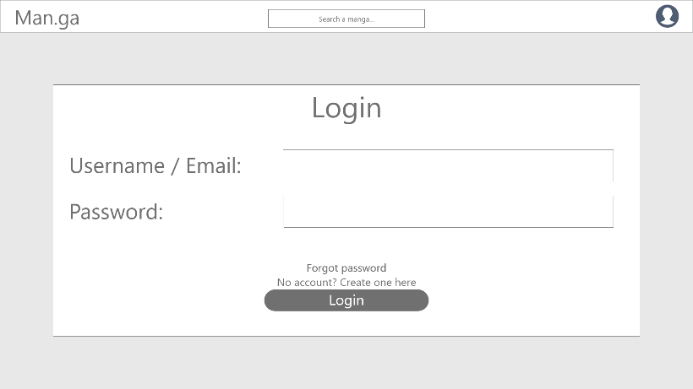

If you forget your password, you will be able to access the password recovery page, which will then ask you to enter your username and email address in order to send you a new password for your account by email.

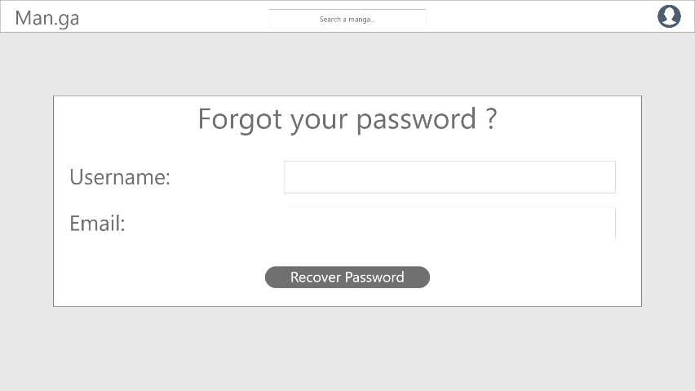

# VI- Profile

Once connected to the site, it will be possible to access your profile, by clicking on the icon available in the header, this will take you to the page containing your personal information.  
Your username and email address will be visible while you will be able to change your password and email address in case of errors or leaks of your information.

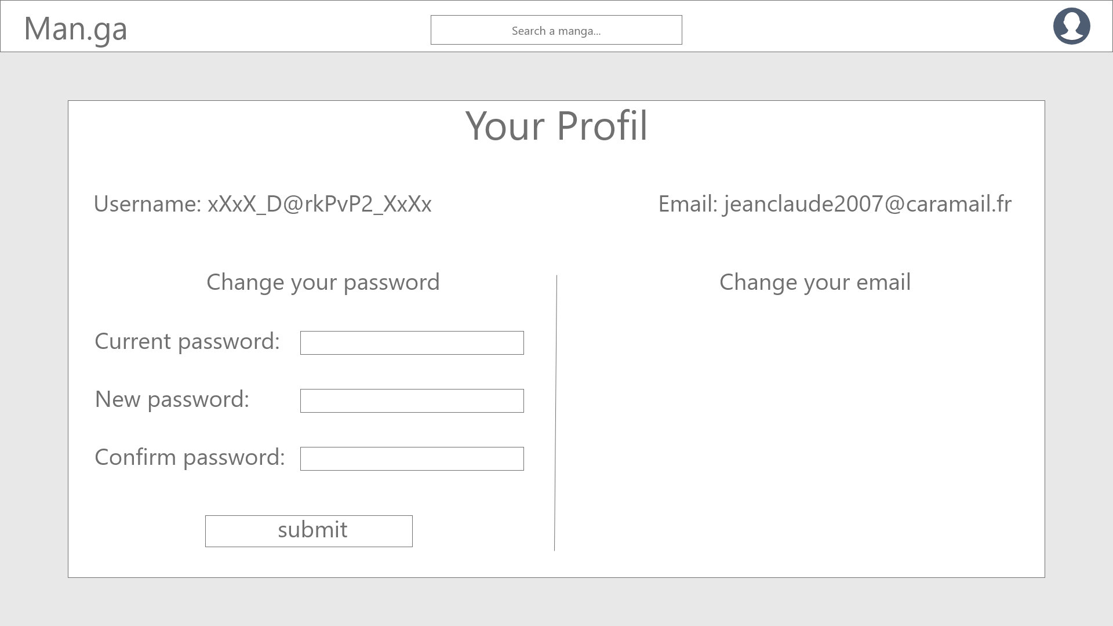

# VII- Footer

The footer currently only contains a link to the information and a link to contact us. If we create a Facebook group or twitter page in the future, we will make sure to add links to it inside this footer.  
Among the two available links, the first one leads to a page that contains a description of our site so that anyone can understand our ambition and the objective of such a site.  
While the second is a form to fill in in case visitors would like to contact us either to ask us questions or to suggest improvements to our site.  
For this purpose, it will be necessary to provide an email address to which we will contact the visitor in return to answer his request or thank him for his participation in the development of our site. It will also be necessary to specify a title for the subject to be addressed and to fill in the text box provided for the expression of the visitor's request.